**https://ensurekar.com/fssai-food-license**

**fssai food license**

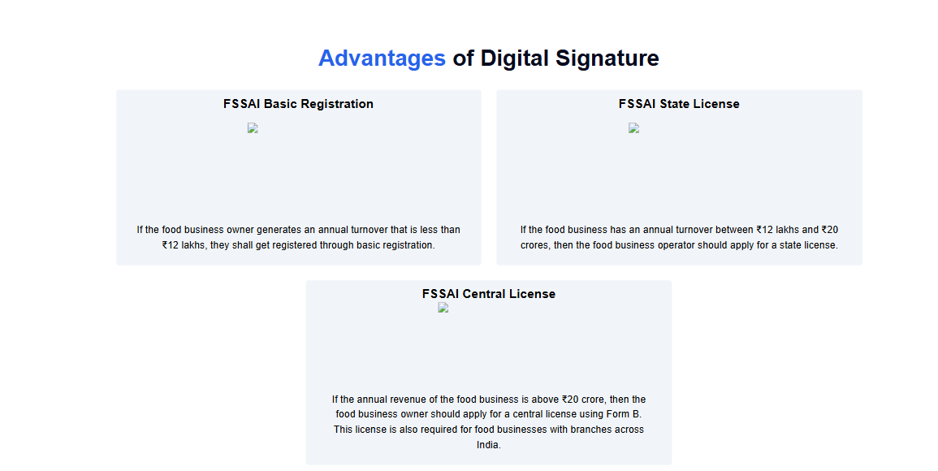

**FSSAI Basic Registration**



**FSSAI State License**



**FSSAI Central License**

